Jenkins
Lab Book

Copyright © 2011 IGATE Corporation. All rights reserved. No part of this publication shall be reproduced in any way, including but not limited to photocopy, photographic, magnetic, or other record, without the prior written permission of iGATE Corporation.


IGATE Corporation considers information included in this document to be Confidential and Proprietary.

Document Revision History

Date | Revision No. | Author | Summary of Changes
24/05/2013 | 0.1 | Rathnajothi Perumalsamy | First version

Table of Contents
Document Revision History 2
Table of Contents 3
Getting Started 5
Overview 5
Setup Checklist for Jenkins 5
Instructions 5
Learning More (Bibliography if applicable) 5
Lab 1. Installing and running Jenkins 6
1.1: Installing Jenkins 6
1.1.1: As a standalone application 6
1.1.2: As a windows service 7
1.2: <<TODO> 7
Lab 2. Jenkins Configuration 8
2.1: Configuring Jenkins 8
2.1.1: Configuring JDK 8
2.1.2: Configuring ANT 9
2.1.3: Email Configuration in Jenkins 9
Lab 3. Build Job creation in Jenkins 11
3.1: Creating build job in Jenkins 11
3.2: Configure build job in Jenkins 11
3.3: Configure SCM 12
3.3: Scheduling job execution 13
3.4: Invoke Ant 14
<<TODO>> 15
Lab 4. Automated deployment and continuous delivery 16
4.1: Installation of Deploy plug-in 16
4.2: Automate deployment of an application 16
<<TODO>> 18
Lab 5. Automating Testing using Jenkins 19
5.1: Automate unit testing of an application 19
<<TODO>> 20
Lab 6. Securing Jenkins 21
6.1: Activating Securing in Jenkins 21
6.2: Creating new users in Jenkins 21
6.3: Authorizing users in Jenkins 22
<<TODO>> 23
Lab 7. Code Quality 24
7.1: Ensuring code quality in Jenkins 24
<<TODO>> 25
Appendices 26
Appendix A: Table of Figures 26

Getting Started

Overview
This lab book is a guided tour for learning Jenkins. It comprises examples and ‘To Do’ assignments. Follow the steps provided in the examples and work out the ‘To Do’ assignments given.

Setup Checklist for Jenkins
Here is what is expected on your machine in order for the lab to work.
Minimum System Requirements
- Intel Pentium 90 or higher (P166 recommended)
- Microsoft Windows 95, 98, or NT 4.0, 2k, XP.
- Memory: 32MB of RAM (64MB or more recommended)
- Internet Explorer 6.0 or higher
- MS-Access/Connectivity to Oracle database
- Apache Tomcat Version 5.0.

Please ensure that the following is done:
- Eclipse 3.5 or above with SVN or CVS plugin is installed.
- JDK 1.5 or above is installed. (This path is henceforth referred as <java_install_dir>)
- ANT OR MAVEN is installed
- Connected to SVN or CVS

Instructions

- Create a directory by your name in drive <drive>. In this directory, create a subdirectory Jenkins_assgn. For each lab exercise create a directory as lab <lab number>.

Learning More (Bibliography if applicable)

- Jenkins Continuous Integration Cookbook by Alan Mark Berg
- Jenkins – The Definitive Guide by John Ferguson Smart

- Installing and running Jenkins

Goals | - Learn to install and start Jenkins
Time | 30 minutes

1.1: Installing Jenkins

1.1.1: As a standalone application
Step 1: Download jenkins.war file from http://jenkins-ci.org and save it into your local disk.
Step 2: Open Command Prompt and change working directory where jenkins.war file exists.
Step 3: Install Jenkins by executing the command as highlighted in the below screen.
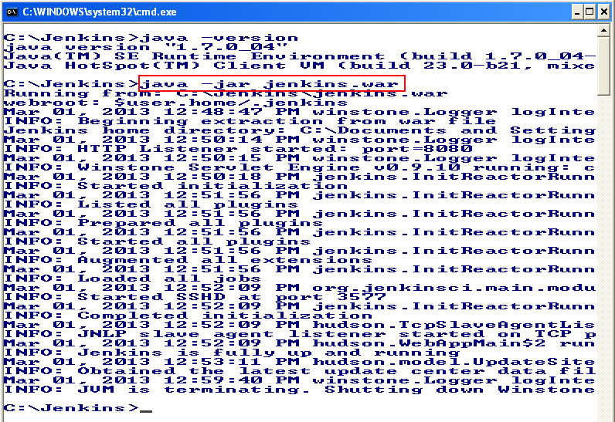
Figure 1: Jenkins Installation

Step 4: Once Jenkins is started, the Jenkins dash board can be accessed by giving the following link in the browser
http://localhost:8080/

1.1.2: As a windows service[Works in Chrome Browser]

Step 1: Start Jenkins as a standalone application.
Step 2: Open Jenkins Dashboard by requesting the URL http://localhost:8080
Step 3: Click “Manage Jenkins” link.
Step 4: Click “Install as Windows Service” button.
Step 5: Select the installation directory of Jenkins and click “Install”.
Step 6: Once Jenkins is successfully installed as a windows service, Jenkins dashboard will always be accessible by requesting the URL http://localhost:8080

1.2: <<TODO>
Install and run Jenkins as a windows Service

- Jenkins Configuration

Goals | At the end of this lab session, you will be able to understand:  - How to configure Jenkins
Time | 30 minutes

2.1: Configuring Jenkins
Step 1: Open Jenkins Dashboard by requesting the URL http://localhost:8080
Step 2: Click “Manage Jenkins” link.
Step 3: Click on “Configure System” Link and fill the field values as shown below:

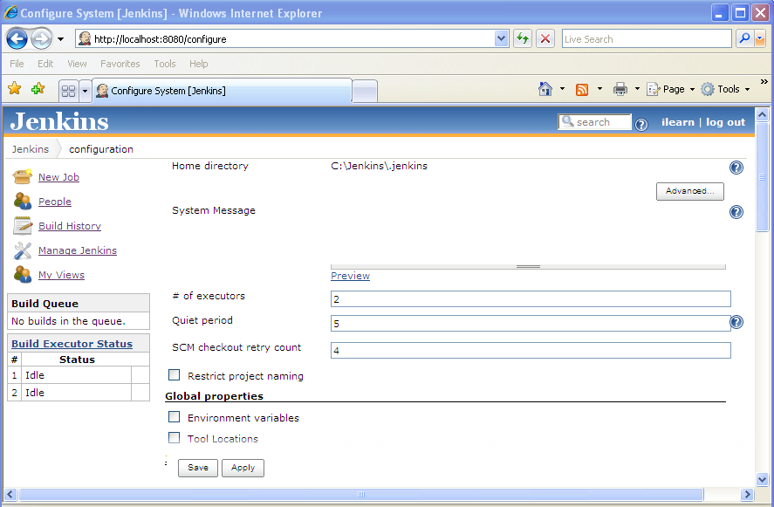

Figure 2: Configure System

2.1.1: Configuring JDK
Step 1: Type name of the JDK. For example, JENKINS_JDK
Step 2: Specify the JDK installation directory

 JDK installation can be automated by following the below steps
- Check “Install Automatically” option in JDK section
- Select the option to download required JDK version and install.

2.1.2: Configuring ANT
Step 1: Type name of the ANT installation in Name field under ANT section. For example, JENKINS_ANT
Step 2: Specify the ANT installation directory.

ANT installation can be automated by following the below steps
- Check “Install Automatically” option in ANT section
- Select the option to download required ANT version and install.

More than one instance of JDK and ANT can be specified.

2.1.3: Email Configuration in Jenkins
To send a feedback to the developers during build failure, E-mail notification configuration is mandatory.
Step 1: Specify details such as SMTP server name, sender credentials, SMTP port in E-mail notification section as shown below:
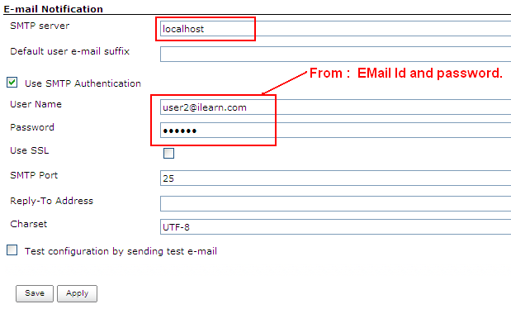
Figure 3: E-mail Configuration

Step 2: Test Email configuration by checking “Test Configuration by sending test e-mail” field and type “Recipient Address” as shown below:

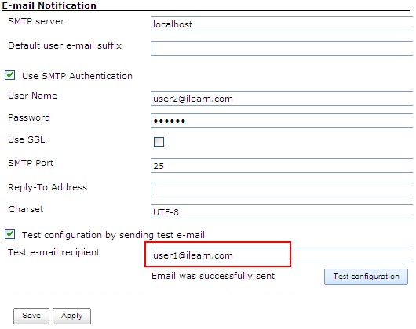

Figure 4: Testing E-mail configuration

Step 3: Test Email will be sent successfully, if the configuration is done correctly.

- Build Job creation in Jenkins

Goals | At the end of this lab session, you will be able to understand:  - How to create build job and configure build job  - Scheduling build job  - Execution of project in jenkins
Time | 120 minutes

3.1: Creating build job in Jenkins
Step 1: Open Jenkins Dashboard by requesting the URL http://localhost:8080
Step 2: Click “New Job” link.
Step 3: Type job name and select type of project as shown below:
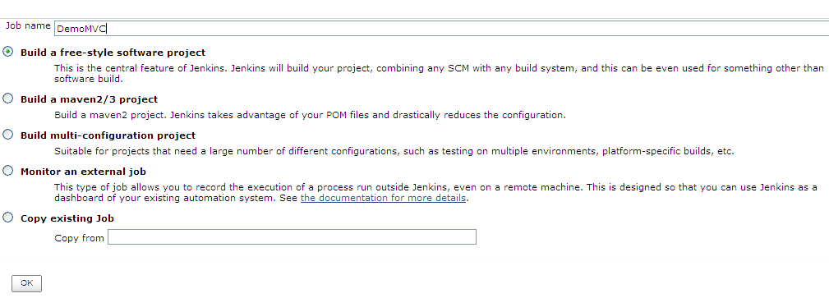
Figure 5: Build job Creation

Step 4: Click ok

3.2: Configure build job in Jenkins
Step 1: Type the description of the project in the “Project Configuration” page (Which will be displayed once build job is created at first time otherwise manually this page should be opened) as shown below:

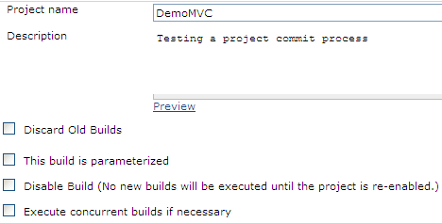

Figure 6: Project Configuration

3.3: Configure SCM
Step 1: Open “Project Configuration” page
Step 2: Select “Subversion” in SCM section
Step 3: Specify Repository URL
Step 4: Type “.” in Local module directory field to avoid creation of new directory for source in Local workspace as shown below:
Step 5: Select Check-out strategy as “Use ‘svn update’ as much as possible, with ‘svn revert’ before update” (which will systematically run svn revert before running svn update)
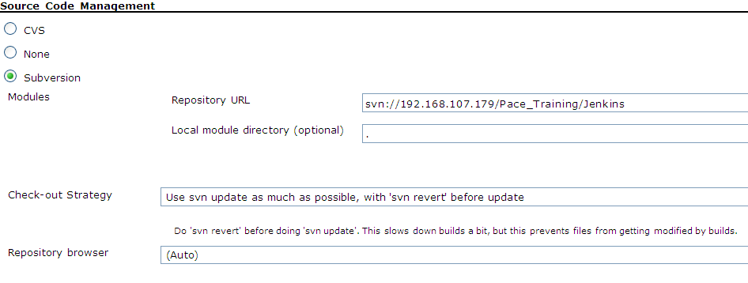
Figure 7: SCM Configuration

For Vaishali Machine
Repository URL
svn://ndafile/ELTP_2015/JEE_Lot/25_June_Batch1/JEE_Batch1_Group1/VaishaliDemoMVC

3.3: Scheduling job execution

Step 1: Open “Project Configuration” page
Step 2: Select “Poll SCM” in Build Triggers section and type * * * * * in the schedule as shown below: (which polls SCM for every change commits and triggers build execution)
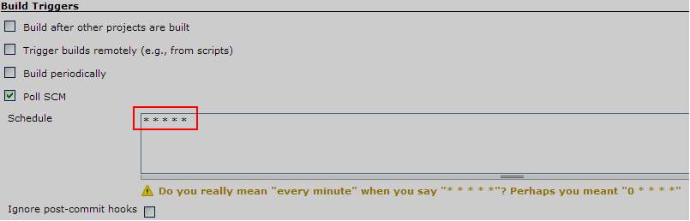

Figure 8: Build scheduling

To build the job periodically, check Build periodically field and type relevant expression in schedule field. For an Example, to build job every day at 8 hours, the expression should be “0 8 * * *”

Cron expression should be created to schedule the job trigger.

* * * * *

1st Field - MINUTES Minutes in one hour (0-59)
2nd Field - HOURS Hours in one day (0-23)
3rd Field - DAYMONTH Day in a month (1-31)
4th Field - MONTH Month in a year (1-12)
5th Field - DAYWEEK Day of the week (0-7) where 0 and 7 are Sunday

To schedule job every minute, use cron expression * * * * *

3.4: Invoke Ant
Step 1: Once SCM is configured, choose “Invoke Ant option” from “Add build step” drop down list in build section as shown below:
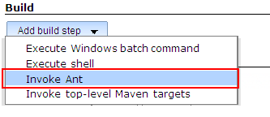
Figure 9: Invoking Ant

Step 2: Specify the Ant version and type target name (which need to be executed from your build targets) in Targets field as shown below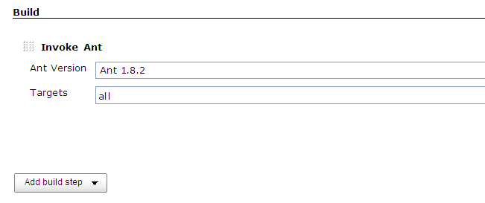

Figure 10: Selecting target in build

:[For Vaishali Machine target =war ] It is there in build .xml]

Step 3: Click on save
Step 4: Schedule the build to be executed immediately and view the console output as shown below:

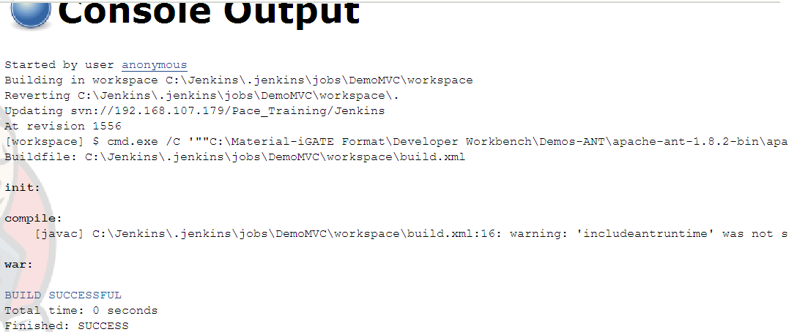

Figure 11: Build execution output

For Vaishali Machine –Steps

<<TODO>>
Create a new project in Jenkins for an application, which should build the project automatically after every 24 hours.

- Automated deployment and continuous delivery

Goals | At the end of this lab session, you will be able to:  - Automate the deployment of an application to a tomcat server
Time | 60 minutes

4.1: Installation of Deploy plug-in
Step 1: Open Jenkins Dashboard by requesting the URL http://localhost:8080
Step 2: Click “Manage Jenkins” link.
Step 3: Click on “Manage Plugins” Link
Step 4: Select “Available” tabs, check “Deploy to container Plugin” and click on Download and install button.

Alternate Approach:

Step 1: Download deploy.hpi file
Step 2: Follow steps 1 to 3 given in Installation of deploy plug-in .[ and Click on advance tab] [Then go to upload plugin option and browse deply.hpi file.]
Step 2: Install plug-in manually by selecting “Advanced tab” and upload plug-in as shown below:
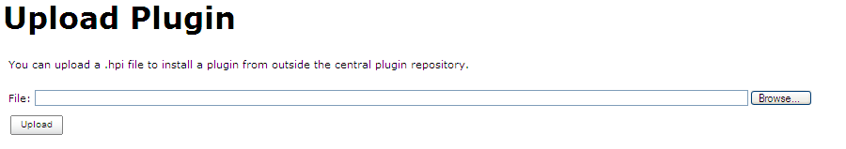

Figure 12: Install plug-in manually

4.2: Automate deployment of an application

Step 1: Open Project (build job) configuration.
Step 2: In Post-build Actions, choose “Deploy war/ear to a container” from “Add post-build action” drop down list
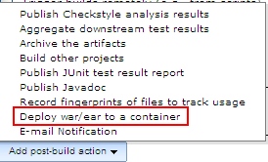

Figure 13: Deploying war file to tomcat server

Step 3: Configure Tomcat server details as shown below:

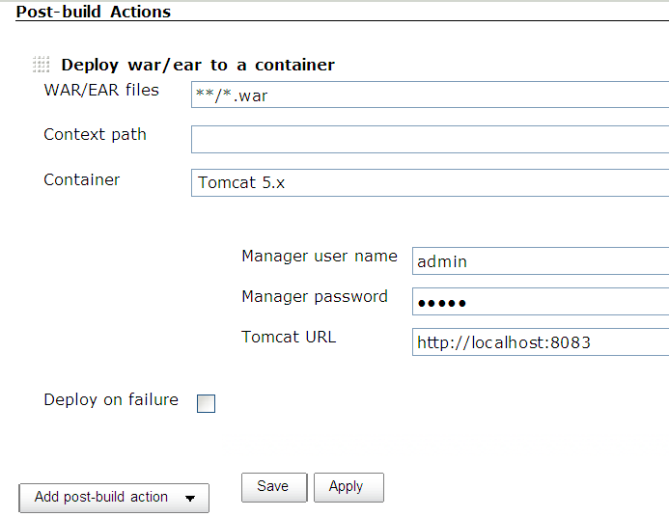

Figure 14: Deployment server configuration details

Step 4: Check Deploy on failure field, in order to send feedback to the developers once build/deployment is failed.
Step 5: choose “E-mail Notification” from “Add post-build action” drop down list as shown below:

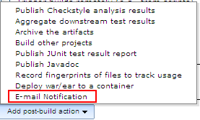

Figure 15: E-mail notification

Step 6: Type recipient mail id and check “Send e-mail for every unstable build.
Step 7: Click on save and schedule the job execution immediately.

<<TODO>>
Create a new project in Jenkins for an application, which should automate the deployment of project into tomcat server.

- Automating Testing using Jenkins

Goals | At the end of this lab session, you will be able to:  - Automate the unit testing of an application
Time | 60 minutes

5.1: Automate unit testing of an application

Step 1: In application build.xml file, ensure target is included to invoke unit test class execution.
Step 2: When build file is executed, automatically test class execution is also invoked.
Step 2: Open Project (build job) configuration.
Step 3: In Post-build Actions, choose “Publish JUnit test result report” from “Add post-build action” drop down list to display test results.

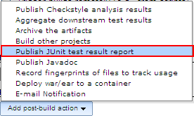

Figure 16: JUnit test result report

Step 4: To generate and publish JUnit test result report, configure report generation as shown below:

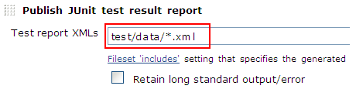
Figure 17: Publishing JUnit test report
Step 5: Once test is build, “Test result Trend” will be displayed in the Project home page as shown below:

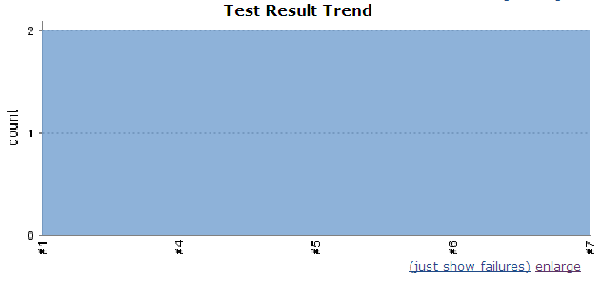

Figure 18: Test Result Trend

Alternate Approach:

Step 5: Once test is build, Click on “Latest Test Result” link in the Project home page as shown below. Detailed test result will be displayed with duration, number of tests failed, etc...

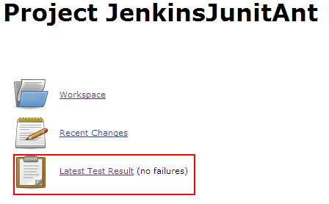
Figure 19: Test Result

<<TODO>>
Create a new project in Jenkins for an application, which should automate unit testing of an application.
- Securing Jenkins

Goals | At the end of this lab session, you will be able to:  - Enable more security in Jenkins
Time | 60 minutes

6.1: Activating Securing in Jenkins

Step 1: Click “Configure Global Security” link in “Manage Jenkins” screen.
Step 2: Check “Enable Security” Field
Step 3: Click on “Jenkins own user database” and select “Allow users to sign up” field under Access Control (To authenticate users based on existing credentials in Jenkins own database and to support new users sign up) as shown below:
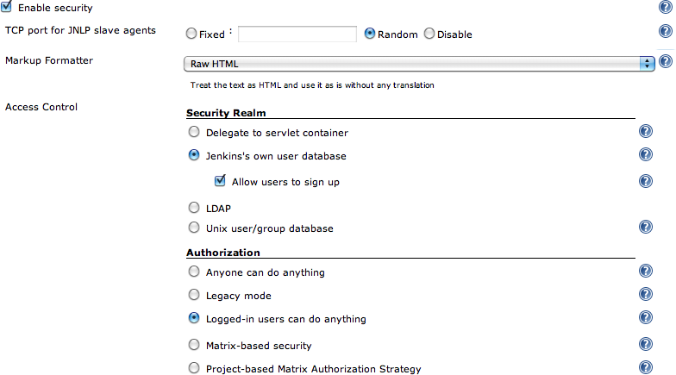

Figure 20: Activating security in Jenkins

6.2: Creating new users in Jenkins
Step 1: Open Jenkins Dashboard
Step 2: Click “sign up” link to create new user.
Step 3: Fill the user’s details and click on Sign up.

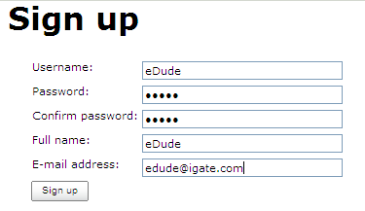
Figure 21: Creating new User

Step 4: View list of created users details by clicking on “Manage Users” link in “Manage Jenkins” screen.

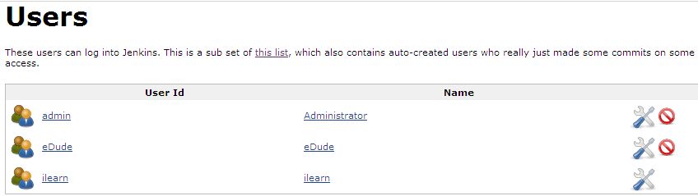

Figure 22: List of existing users

6.3: Authorizing users in Jenkins

Step 1: Click “Configure Global Security” link in “Manage Jenkins” screen.
Step 2: Click “Matrix-based security” under Authorization to authorize the users based on username and assign permissions as shown below.
(As default, Logged-in users can do anything is selected under Authorization).
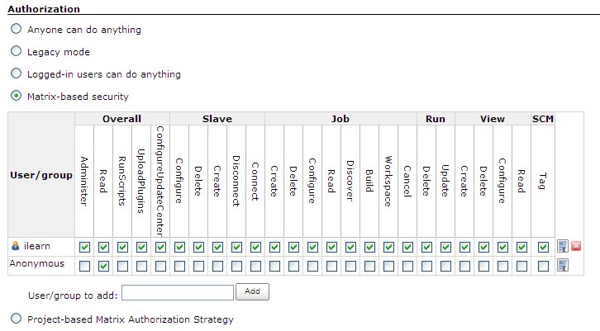

Figure 23: Authorizing Users

Step 3: Click “Project-based Matrix Authorization Strategy” under Authorization to authorize the users based on projects.

<<TODO>>
- Create a new user in Jenkins. Authenticate and authorize new user to schedule a specific job execution. Other users should be allowed to view the job.
- Implement authorization based on project-matrix.

- Code Quality

Goals | At the end of this lab session, you will be able to:  - Ensure quality of the code.
Time | 60 minutes

7.1: Ensuring code quality in Jenkins
Step 1: Install Checkstyle, PMD, and FindBugs plugins.
Step 2: Open Project Configuration screen.
Step 3: In Post-build Actions, choose “Publish Checkstyle analysis report” from “Add post-build action” drop down list as shown below.

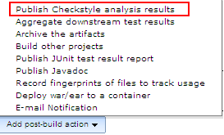

Figure 24: Checkstyle configuration

Step 3: To generate and publish Checkstyle analysis result, configure report generation as shown below:
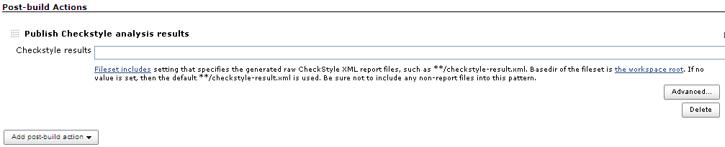

Figure 25: Checkstyle result configuration

(As default, **/Checkstyle-result.xml used as value in Checkstyle results field.)
Step 4: Once job is build, “Checkstyle Trend” will be displayed in the Project home page

Alternate Approach:

Step 4: Once job is executed, the following output displays in build home page.

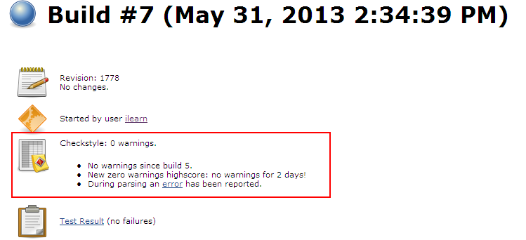

Figure 26: Checkstyle result

<<TODO>>
- Check the quality of the code by configuring checkstyle in existing job.

Appendices

Appendix A: Table of Figures

Figure 1: Jenkins Installation 6
Figure 2: Configure System 8
Figure 3: E-mail Configuration 10
Figure 4: Testing E-mail configuration 10
Figure 5: Build job Creation 11
Figure 6: Project Configuration 12
Figure 7: SCM Configuration 13
Figure 8: Build scheduling 13
Figure 9: Invoking Ant 14
Figure 10: Selecting target in build 15
Figure 11: Build execution output 15
Figure 12: Install plug-in manually 16
Figure 13: Deploying war file to tomcat server 17
Figure 14: Deployment server configuration details 17
Figure 15: E-mail notification 18
Figure 16: JUnit test result report 19
Figure 17: Publishing JUnit test report 19
Figure 18: Test Result Trend 20
Figure 19: Test Result 20
Figure 20: Activating security in Jenkins 21
Figure 21: Creating new User 22
Figure 22: List of existing users 22
Figure 23: Authorizing Users 23
Figure 24: Checkstyle configuration 24
Figure 25: Checkstyle result configuration 24
Figure 26: Checkstyle result 25

